Poetic Diction

🎭 What is Poetic Diction
# Source: AI Source: Provided by: [Data Path: Persons Table -> ID Column: 1, Name_En Column: Motasem Essam] -> From: [Chatgpt (GPT-4-turbo)] on [7/30/2025]
Poetic diction refers to the elevated, artistic, and often figurative language used in poetry (and poetic prose) to evoke emotions, paint vivid imagery, and create musical or rhythmic effects.

✅ Key Features:
# Source: AI Source: Provided by: [Data Path: Persons Table -> ID Column: 1, Name_En Column: Motasem Essam] -> From: [Chatgpt (GPT-4-turbo)] on [7/30/2025]
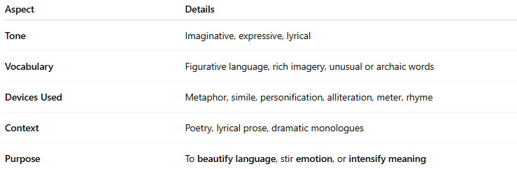
Aspect | Details
Tone | Imaginative, expressive, lyrical
Vocabulary | Figurative language, rich imagery, unusual or archaic words
Devices Used | Metaphor, simile, personification, alliteration, meter, rhyme
Context | Poetry, lyrical prose, dramatic monologues
Purpose | To beautify language, stir emotion, or intensify meaning

🧠 Examples of Poetic Diction:
# Source: AI Source: Provided by: [Data Path: Persons Table -> ID Column: 1, Name_En Column: Motasem Essam] -> From: [Chatgpt (GPT-4-turbo)] on [7/30/2025]
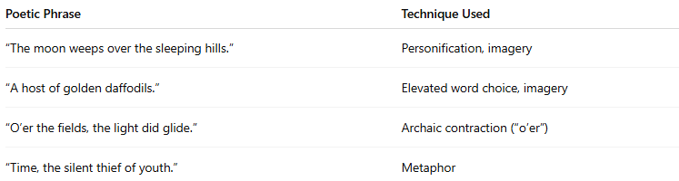
Poetic Phrase | Technique Used
“The moon weeps over the sleeping hills.” | Personification, imagery
“A host of golden daffodils.” | Elevated word choice, imagery
“O’er the fields, the light did glide.” | Archaic contraction (“o’er”)
“Time, the silent thief of youth.” | Metaphor

✍️ Example Sentence Using Poetic Diction:
# Source: AI Source: Provided by: [Data Path: Persons Table -> ID Column: 1, Name_En Column: Motasem Essam] -> From: [Chatgpt (GPT-4-turbo)] on [7/30/2025]
“Upon the dusky shore, her dreams took flight like whispered winds in twilight's breath.”

🆚 Poetic Diction vs Other Types:
# Source: AI Source: Provided by: [Data Path: Persons Table -> ID Column: 1, Name_En Column: Motasem Essam] -> From: [Chatgpt (GPT-4-turbo)] on [7/30/2025]
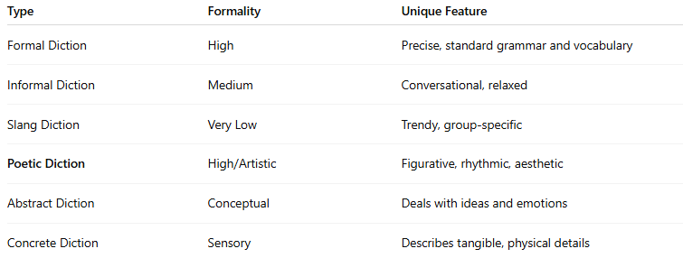
Type | Formality | Unique Feature
Formal Diction | High | Precise, standard grammar and vocabulary
Informal Diction | Medium | Conversational, relaxed
Slang Diction | Very Low | Trendy, group-specific
Poetic Diction | High/Artistic | Figurative, rhythmic, aesthetic
Abstract Diction | Conceptual | Deals with ideas and emotions
Concrete Diction | Sensory | Describes tangible, physical details

🧭 Used In:
# Source: AI Source: Provided by: [Data Path: Persons Table -> ID Column: 1, Name_En Column: Motasem Essam] -> From: [Chatgpt (GPT-4-turbo)] on [7/30/2025]
- Poetry and sonnets
- Literary fiction
- Speechwriting
- Romantic or dramatic expressions

